Developing an API for a Distributed Environment

Question 1:Run the API.py code. Take a screenshot of the terminal output. What command did you use to compile and run the code?
The application can be executed using the following methods:
- api.py
- flask - - app api run - -
- flask - - app api shell
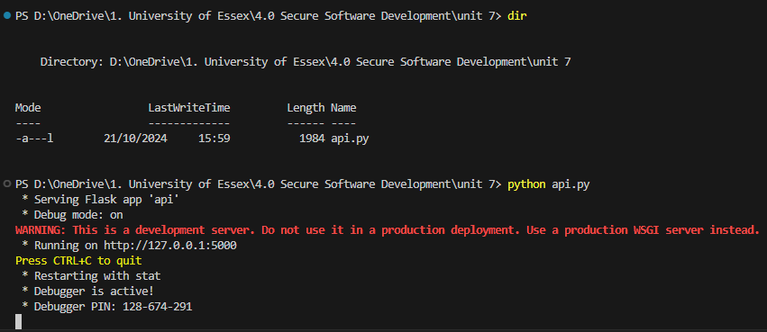

Question 2:Run the following command at the terminal prompt: w3m http://127.0.0.1:5000/user/Ann. What happens when this command is run, and why?
The following error is produced
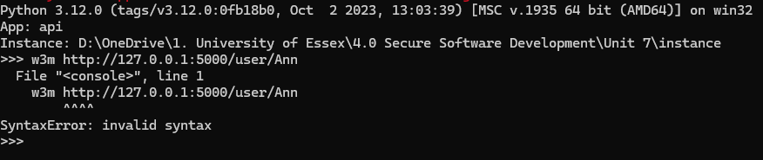
However, when the address is entered into a web-browser the detail for the user =Ann are displayed
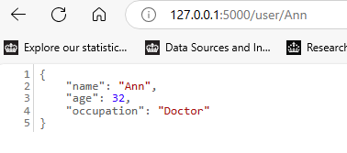

Question 3:Run the following command at the terminal prompt: w3m http://127.0.0.1:5000/user/Adam. What happens when this command is run, and why?
Similarly, ‘Adam’ is not found in the database. The only users are James, Jason and Ann. Flask returns an ‘user not found’ response.

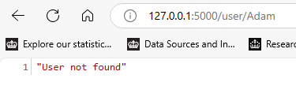

Question 4: What capability is achieved by the flask library?
The flask library allows can be used to develop an API where the database can be amended with CRUD functions via a simple API web interface, following REST protocols

Code
from flask import Flask
from flask_restful import Api, Resource, reqparse

app = Flask(__name__)
api = Api(app)

users = [
{
"name": "James",
"age": 30,
"occupation": "Network Engineer"
},
{
"name": "Ann",
"age": 32,
"occupation": "Doctor"
},
{
"name": "Jason",
"age": 22,
"occupation": "Web Developer"
}
]

class User(Resource):
def get(self, name):
for user in users:
if(name == user["name"]):
return user, 200
return "User not found", 404

def post(self, name):
parser = reqparse.RequestParser()
parser.add_argument("age")
parser.add_argument("occupation")
args = parser.parse_args()

for user in users:
if(name == user["name"]):
return "User with name {} already exists".format(name), 400

user = {
"name": name,
"age": args["age"],
"occupation": args["occupation"]
}
users.append(user)
return user, 201

def put(self, name):
parser = reqparse.RequestParser()
parser.add_argument("age")
parser.add_argument("occupation")
args = parser.parse_args()

for user in users:
if(name == user["name"]):
user["age"] = args["age"]
user["occupation"] = args["occupation"]
return user, 200

user = {
"name": name,
"age": args["age"],
"occupation": args["occupation"]
}
users.append(user)
return user, 201

def delete(self, name):
global users
users = [user for user in users if user["name"] != name]
return "{} is deleted.".format(name), 200

api.add_resource(User, "/user/<string:name>")

app.run(debug=True)

